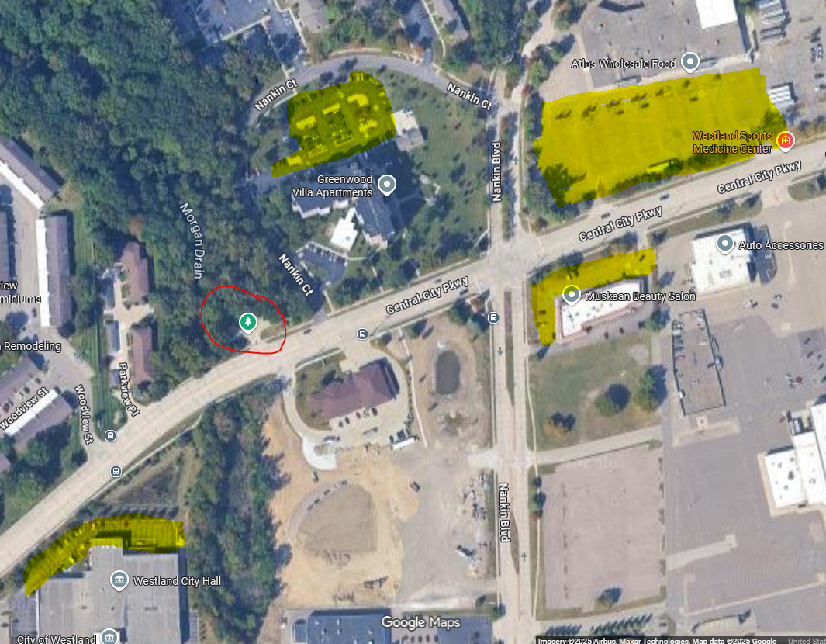
Highlighted sections in yellow indicate open parking spaces. The trailhead entrance is circled in red.

